**GUI for online Booking Cab**

REPORT

**BACHELOR OF TECHNOLOGY**

**in**

**COMPUTER SCIENCE AND ENGINEERING**

By:

|  |  |  |  |
| --- | --- | --- | --- |
| *S.no.* | *Name* | *Roll No.* | *Registration no.* |
| *1.* | Singamsetty Adarsh kumar | *34* | 11902462 |
| *2.* | Pokuri Praveen Reddy | *56* | 11913558 |
| *3.* | Yerragunta Jashwanth Reddy | *47* | 11906192 |

**Group - 1**

**Courses Code: INT213**

**School of Computer Science and Engineering**

Lovely Professional University

Phagwara, Punjab (India)

**Objective**

The primary objective of this project is to implement what we’ve learnt throughout our course of python programming and use that to develop a Graphical User Interface (GUI) for Online Cab Booking. This project also aims at providing a user friendly interface to the users to let them easily use the online cab system so that the lack of knowledge in online booking will be achieved. This project will also help in spreading awareness regarding online booking for people around will aware of different criteria, that are included in online booking.

This Online Cab Booking helps people to book the cabs by using their mobiles. They can also pay amount in online also. Now a days most people are booking their cabs in websites such as OLA, UBER, TAPZO etc.

In [India](https://en.wikipedia.org/wiki/India), most taxicabs, especially those in [Delhi](https://en.wikipedia.org/wiki/Delhi) and [Mumbai](https://en.wikipedia.org/wiki/Mumbai), have distinctive black and yellow liveries with the bottom half painted black and upper half painted yellow. In [Kolkata](https://en.wikipedia.org/wiki/Kolkata), most taxis are painted yellow with a blue strip in the middle. Private companies operating taxis can have their own liveries but need to get them approved from the government. Now drivers don’t need to pay commission.

**Introduction**

Online Car Booking management System is developed to manage all cab hiring work online. It useful for car booking agency that are specialized in Hiring cabs to customers. Using this system many car-booking agency are moving ahead to become a pioneer in the vehicle rental industry by completely focusing on customers. Using this system it is very easy for customer to book a car online and car-booking agency can also track their booking online. So it is also very useful for car booking agency. It is an online system through which customers can view available cabs; register the cabs, view profile and book cabs. Mostly peoples use cab service for their daily transportations need. Car booking agency can also check which car is free for booking and which cars are on booking at present time. The objective and scope of my project Online Cab or car booking System is to record the details various activities of user. It will simplify the task and reduce the paper work. Using this car booking management system car owner can also become partner of car booking agency by giving their car for booking.

**Details of all pages with screenshots:**

* **Registration Page:**

**In this page the new users enter their details and password to create their account to book the cab.**

**This page has fields like first name, last name, mobile number, gender, email, password. The user fills these and clicks on register to get enrolled.**

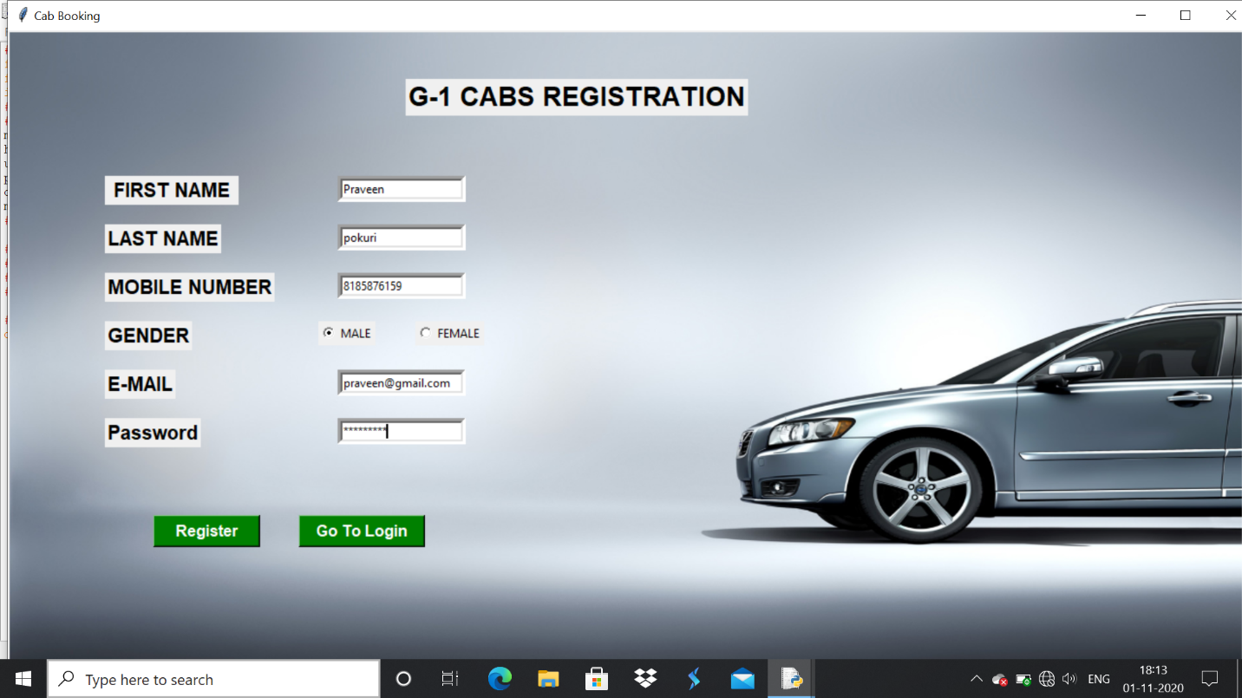

* **Login Page:**

**After registering click on “go to login” button on the registration page which opens a new window for login.**

**In this page users are supposed to login using their registered email and password correctly. Once they enter correct details and click on login they are directed home page of the cab booking system.**

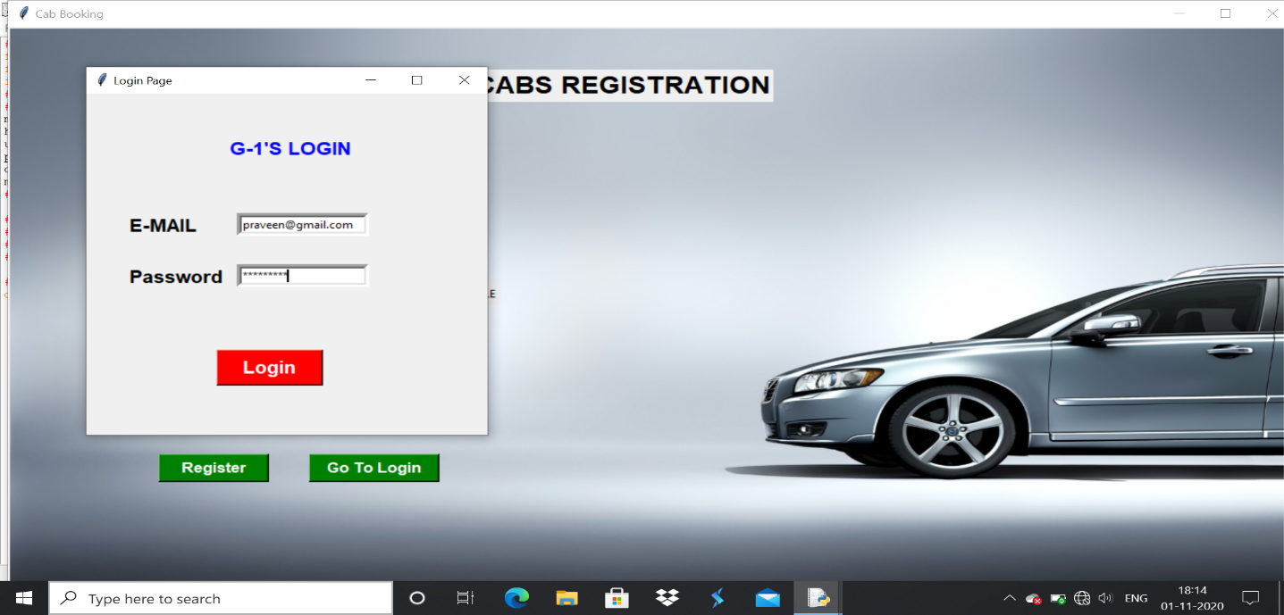

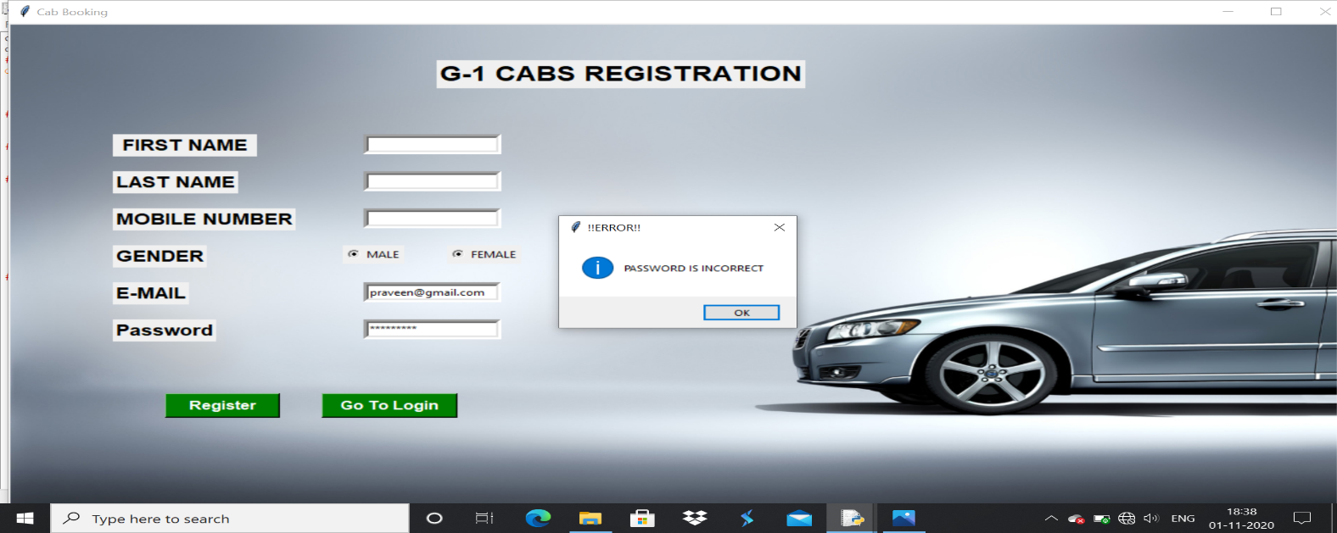**If we enter wrong password it shows a message box**

* **Home Page:**

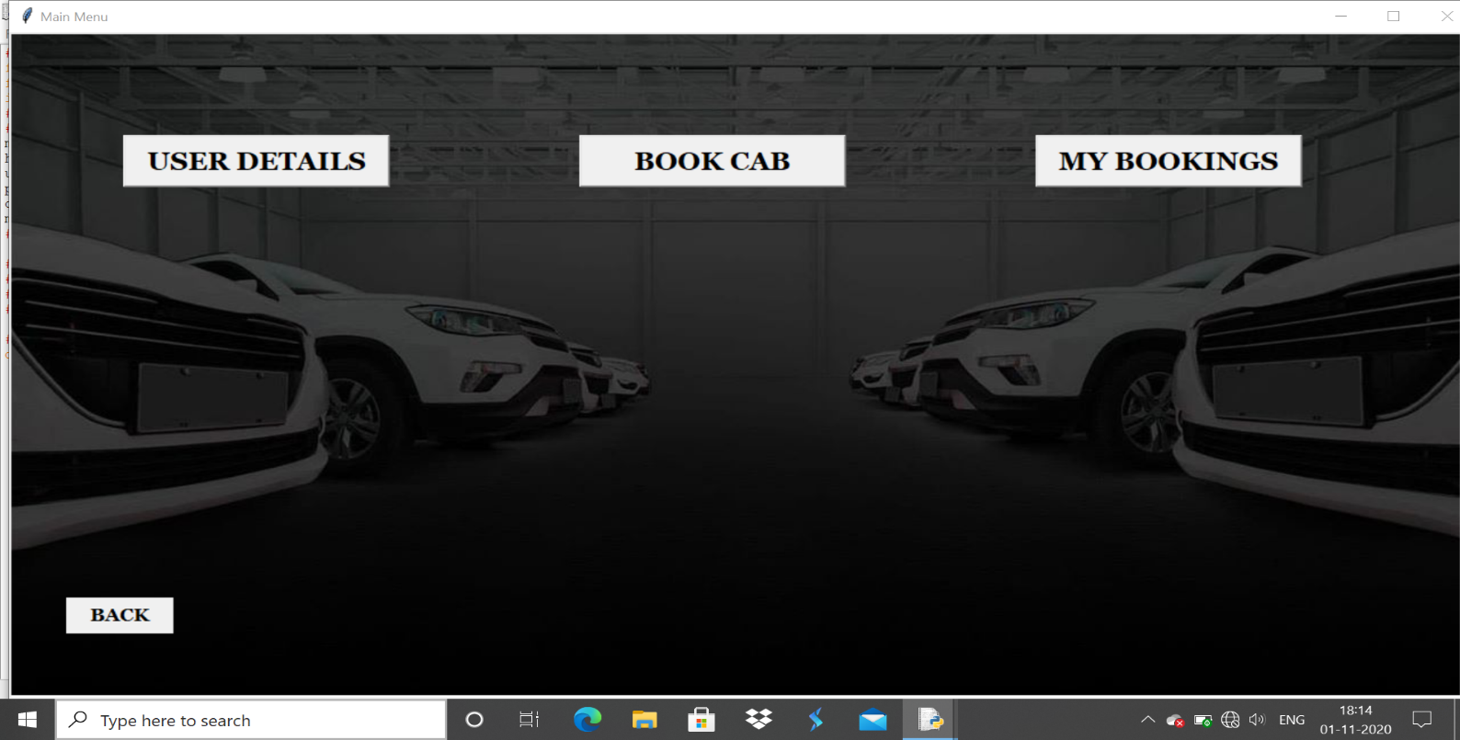**This performs three main operations with the help of buttons one is booking of cab, second is checking the user details, third is checking the booking details after booking.**

* **Booking Page:**

**This page allows the user to enter the details of the traveler like name, age, gender, avenue, time(with hours and minutes), mobile number.**

**And a button named select cab to go to next window for selecting your required cab and then click on book which makes his booking successful.**

**The back button destroys the present window and shows the previous window.**

* 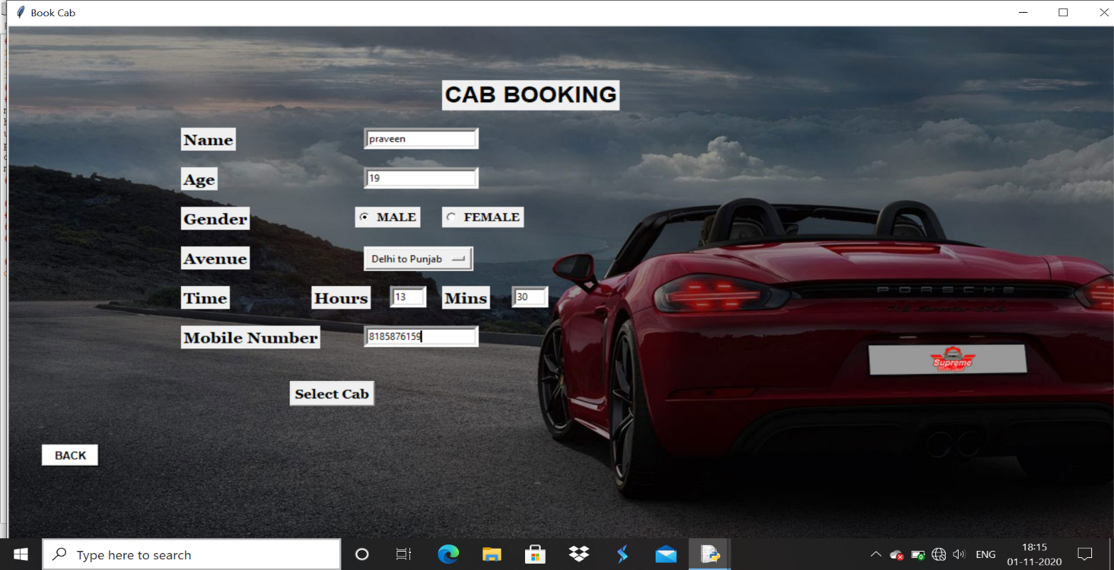**Select Cab:**

**This page contains some of the cabs names with their images which makes customer to select easily, so customer need to select on cab click on book.**

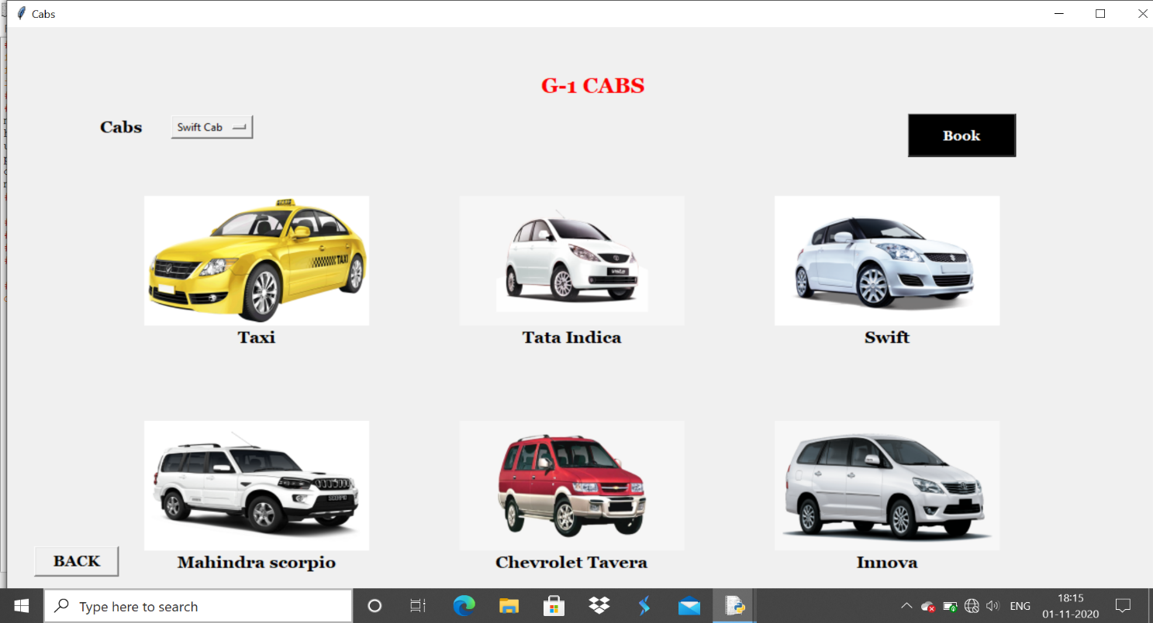

* **User Details:**

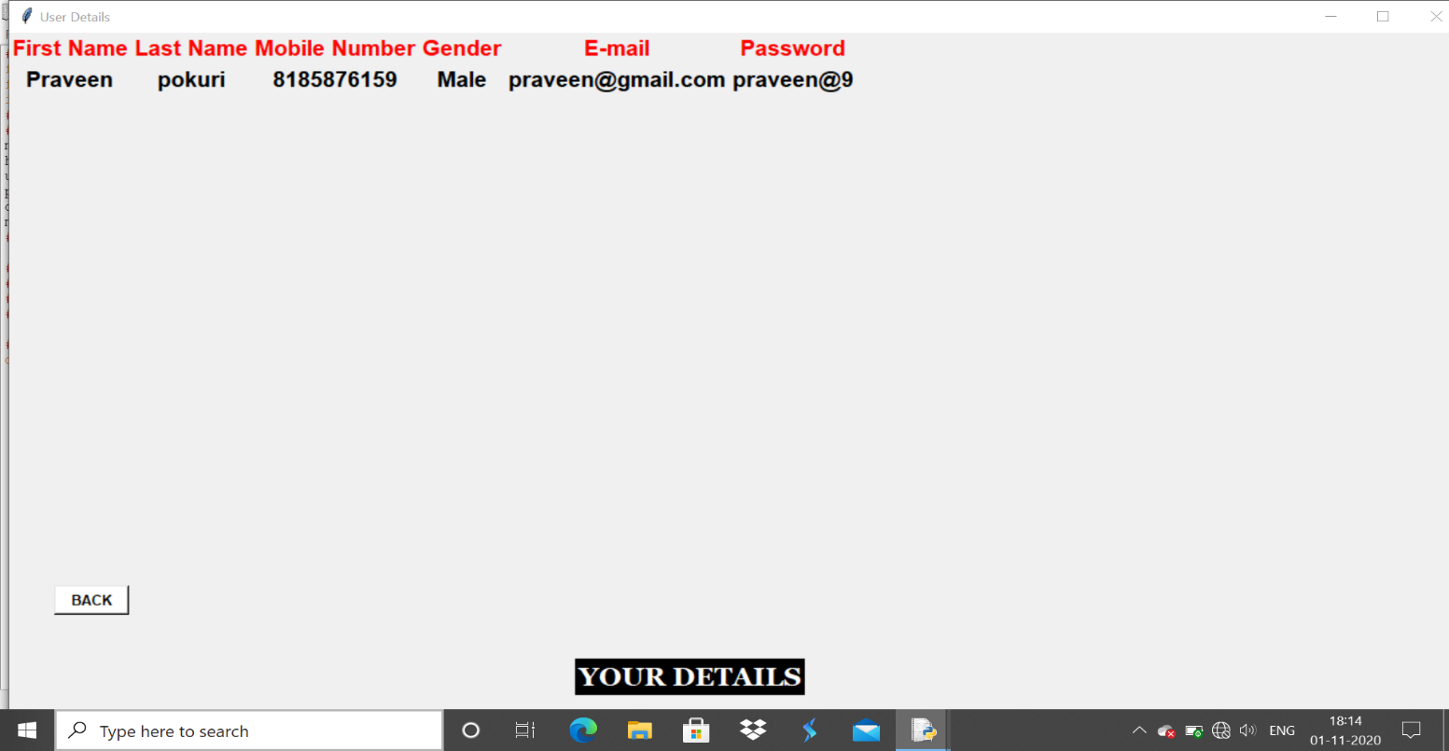**This is present in the home page this stores and show the data of the user which is entered during his/her registration, for this I used data base(cab) and created a table called “user details” and this table stores the details of the registered users.**

* **My Bookings:**

**This is also another window in which all the details given by the customer during booking which include name, age, mobile number, gender, time (hour, minute),**

**Avenue, booked cab name are shown after every successful booking by the user**

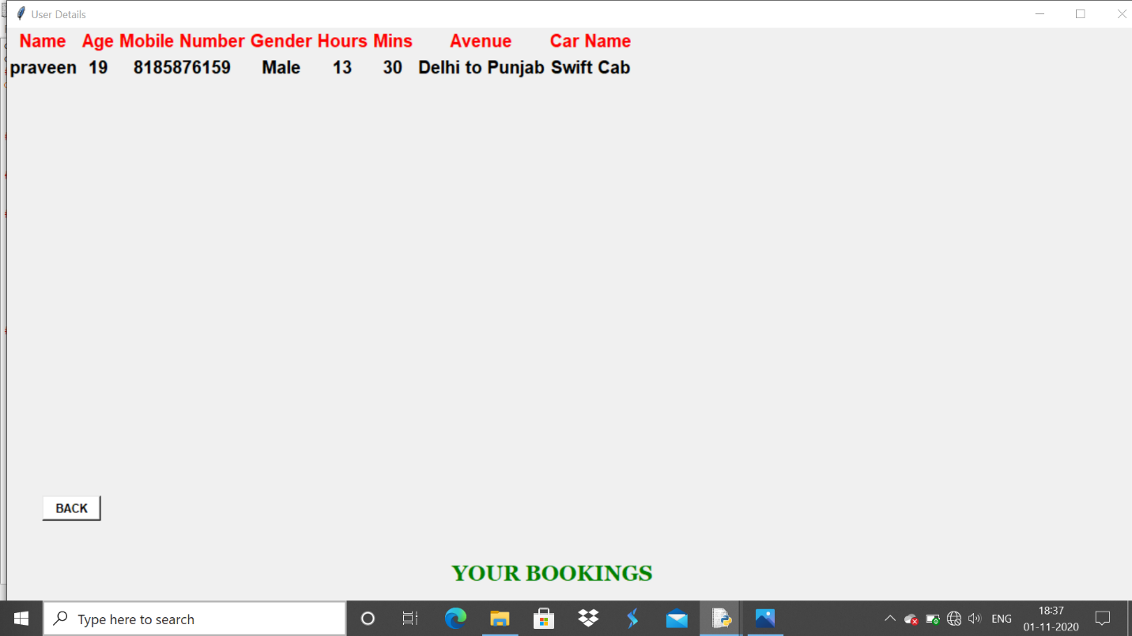

**Source Code:**

**#======IMPORT REQURIED MODULES FROM TKINTER=========#**

**from tkinter import * #this is to import required from tkinter**

**from tkinter import messagebox #Imported message box**

**import mysql.connector #Imported mysql connector to connect to database**

**#========CONNECTING TO DATABASE OF MYSQL============#**

**#The below are details of my data base**

**mb=mysql.connector.connect(**

**host="localhost", #host name for mysql**

**user="praveen", #my user name for mysql**

**password="Praveen@9", #my password to open and work with mysql**

**database="cab") #name of my data base created**

**mycursor=mb.cursor()**

**#==========CREATING OF TABLES IN DATABASE==============#**

**#Created my first table in cab database to store and show user details**

**#mycursor.execute("create table userdetails (First_Name varchar(255), Last_Name varchar(255), Mobile_Number varchar(255),gender varchar(255),email varchar(255),password varchar(255))")**

**#Created my second table in cab database to store and show bookings of the user**

**#mycursor.execute("create table mybookings (Name varchar(255), Age int, Mobile_Number varchar(30), gender varchar(255),Hours int,Min int, Avenue varchar(255), Car_Name varchar(255))")**

**#======VERIFY EMAIL ID AND PASSWORD IN LOGIN==========#**

**def submit(): #Function to verify email and password**

**#selects email,password from userdetails**

**mycursor.execute("select email,password from userdetails")**

**x=mycursor.fetchall() #fetches the selected**

**mail=Email.get() #gets email from table**

**key=Password.get() #gets password from table**

**if(len(mail)==0 or len(key)==0): #checks if the email and password are entered**

**messagebox.showinfo("!!ERROR!!", "PLEASE FILL IN THE DATA") #displays message box to enter all feilds**

**if ('@' not in mail): #checks the entered email is correct are not**

**messagebox.showinfo("!!ERROR!!", "PLEASE PROVIDE A VALID MAIL ID") #displays message box**

**else:**

**pass**

**if(len(key)<6): #checks if the password length is less than 6**

**messagebox.showinfo("!!ERROR!!","PLEASE ENSURE LENGTH OF PASSWORD(ATLEAST 6)")**

**else:**

**pass**

**for i in x: #checks the email and password in database**

**if(mail in i[0]):**

**if(key in i[1]):**

**mb.commit() #commit is to execute in database**

**main_menu() #calls the main_memu function**

**else:**

**messagebox.showinfo("!!ERROR!!","PASSWORD IS INCORRECT") #checks the password is correct are not**

**else:**

**pass**

**#==============SAVE BOOKINGS MADE BY USER=============#**

**def savebookings(): #Function to store or save user bookings in database**

**#messagebox.showinfo("Message","Cab Booked Successfully")**

**#to insert the booking details into the table from tkinter window**

**mycursor.execute("insert into mybookings values(%s,%s,%s,%s,%s,%s,%s,%s)", (Name.get(),Age.get(), Mobile_Number.get(), var1.get(), Hours.get(),Mins.get(),clicked.get(),car.get()))**

**#to commit the action done above**

**mb.commit()**

**#to set the values to NULL on the window after they are inserted in the table**

**Name.set("")**

**Age.set("")**

**Mobile_Number.set("")**

**Hours.set("")**

**Mins.set("")**

**#============SHOW BOOKINGS MADE BY USER===============#**

**def showbookings(): #Function to show the bookings made by the user**

**top6=Toplevel() #Toplevel is used for creating a new window on the existing window**

**top6.title("User Details") #to set the title of the window**

**top6.geometry('1300x700') #to set the geometry of the window**

**#Lable is to print some text on the window and palce is position of the lable**

**Label(top6,text="YOUR BOOKINGS",font=('georgia 18 bold'),fg='green').place(x=500,y=600)**

**#executes the command ie; selects all the data in the table mybookings**

**mycursor.execute("select * from mybookings")**

**#fetches all the selected data from table**

**x=mycursor.fetchall()**

**#BACK button destroys the existing window**

**b1=Button(top6,text="BACK",fg="black",bg="white",height=1,width=7,font=('time 10 bold'),relief=RAISED,command=top6.destroy)**

**b1.place(x=40,y=530)**

**#All the below lines are lables used to dispaly text**

**#grid is same palce but places in the form of rows and columns(in tables)**

**Label(top6, text="Name",font=('time 15 bold'),fg='red').grid(row=0, column=0)**

**Label(top6, text="Age",font=('time 15 bold'),fg='red').grid(row=0, column=1)**

**Label(top6, text="Mobile Number",font=('time 15 bold'),fg='red').grid(row=0, column=2)**

**Label(top6, text="Gender",font=('time 15 bold'),fg='red').grid(row=0, column=3)**

**Label(top6, text="Hours",font=('time 15 bold'),fg='red').grid(row=0, column=4)**

**Label(top6, text="Mins",font=('time 15 bold'),fg='red').grid(row=0, column=5)**

**Label(top6, text="Avenue",font=('time 15 bold'),fg='red').grid(row=0, column=6)**

**Label(top6, text="Car Name",font=('time 15 bold'),fg='red').grid(row=0, column=7)**

**r=1 #initilize c(column) value to 1**

**for i in x: #to print the data from the table in the database on to window**

**Label(top6, text=i[0],font=('time 15 bold')).grid(row=r ,column=0)**

**Label(top6, text=i[1],font=('time 15 bold')).grid(row=r ,column=1)**

**Label(top6, text=i[2],font=('time 15 bold')).grid(row=r ,column=2)**

**Label(top6, text=i[3],font=('time 15 bold')).grid(row=r ,column=3)**

**Label(top6, text=i[4],font=('time 15 bold')).grid(row=r ,column=4)**

**Label(top6, text=i[5],font=('time 15 bold')).grid(row=r ,column=5)**

**Label(top6, text=i[6],font=('time 15 bold')).grid(row=r ,column=6)**

**Label(top6, text=i[7],font=('time 15 bold')).grid(row=r ,column=7)**

**r=r+1 #increment the value of column by one(1)**

**#=============SAVE USER DETAILS TO DATABASE============#**

**def savedata(): #Function to store or save user bookings in database**

**#to insert the user details into the table from tkinter window**

**mycursor.execute("insert into userdetails values(%s,%s,%s,%s,%s,%s)", (First_Name.get(),Last_Name.get(),mobilenumber.get(),var.get(),Email.get(),Password.get()))**

**mb.commit() #executes the above commands**

**#---SETS ALL THE VALUES TO NULL AFTER THEY ARE STORED----#**

**First_Name.set("")**

**Last_Name.set("")**

**mobilenumber.set("")**

**Email.set("")**

**Password.set("")**

**#===========SHOW ALL USER DETAILS ON WINDOW=========#**

**def show(): #function to show the user details entered during the registration**

**top5=Toplevel() #creatation of new window**

**top5.title("User Details") #title of the window**

**top5.geometry('1300x700') #window size**

**#Lable "YOUR DETAILS" which just displays the text on the on the window**

**Label(top5,text="YOUR DETAILS",font=('georgia 18 bold'),fg='white',bg='black').place(x=500,y=600)**

**#selects all the details in userdetails**

**mycursor.execute("select * from userdetails")**

**#fetch all the data in table**

**x=mycursor.fetchall()**

**#BACK which destroys the existing window**

**b1=Button(top5,text="BACK",fg="black",bg="white",height=1,width=7,font=('time 10 bold'),relief=RAISED,command=top5.destroy)**

**b1.place(x=40,y=530)**

**#All the below lines are lables which displays the text over window**

**Label(top5, text="First Name", fg='red',font=('time 15 bold')).grid(row=0, column=0)**

**Label(top5, text="Last Name", fg='red',font=('time 15 bold')).grid(row=0, column=1)**

**Label(top5, text="Mobile Number", fg='red',font=('time 15 bold')).grid(row=0, column=2)**

**Label(top5, text="Gender", fg='red',font=('time 15 bold')).grid(row=0, column=3)**

**Label(top5, text="E-mail", fg='red',font=('time 15 bold')).grid(row=0, column=4)**

**Label(top5, text="Password", fg='red',font=('time 15 bold')).grid(row=0, column=5)**

**r=1 #initlize the value of row by 1(one)**

**for i in x: #for loop to print the details from data base on window**

**Label(top5, text=i[0],font=('time 15 bold')).grid(row=r ,column=0)**

**Label(top5, text=i[1],font=('time 15 bold')).grid(row=r ,column=1)**

**Label(top5, text=i[2],font=('time 15 bold')).grid(row=r ,column=2)**

**Label(top5, text=i[3],font=('time 15 bold')).grid(row=r ,column=3)**

**Label(top5, text=i[4],font=('time 15 bold')).grid(row=r ,column=4)**

**Label(top5, text=i[5],font=('time 15 bold')).grid(row=r ,column=5)**

**r=r+1 #increment of the row by one(1)**

**#===========LOGIN PAGE OF THE CAB BOOKING==============#**

**def login(): #function to execute the login page**

**top2=Toplevel() #window of the login page**

**top2.title("Login Page") #title of the window**

**top2.geometry('400x400') #window size**

**#heading on the top of the window**

**Label(top2,text="G-1'S LOGIN",font=('time 15 bold'),fg='blue').place(x=140,y=50)**

**#lable showing text "E-MAIL"**

**Label(top2,text="E-MAIL",font=('time 15 bold')).place(x=40,y=140)**

**#entry box to enter the email**

**e1=Entry(top2,bd=5,textvariable=Email)**

**e1.place(x=150,y=140) #position of the entry box**

**#lable showing text "Password"**

**Label(top2,text = 'Password',font = ('time 15 bold')).place(x=40,y=200)**

**#show ="*" displays the password in the form of stars(*)**

**e2=Entry(top2,show = '*',bd=5,textvariable=Password)**

**e2.place(x=150,y=200)**

**#b4 is the login button which allows to login to the home page**

**b4=Button(top2,text="Login",fg='white',bg='red',height=1,width=8,font=('time 15 bold'),command=submit)**

**b4.place(x=130,y=300)**

**#=========REGISTRATION PAGE FOR CAB BOOKING=========#**

**root=Tk() #root window**

**root.title('Cab Booking') #title of the window**

**root.geometry("1300x700") # window size**

**#====DEFINING VARIABLES TYPES OF REGISTRATION PAGE=====#**

**First_Name=StringVar()**

**Last_Name=StringVar()**

**mobilenumber=StringVar()**

**Email=StringVar()**

**Password=StringVar()**

**#applying canvas to the window**

**canvas = Canvas(root,width=1300, height=700, bg='white')**

**canvas.pack()**

**#inserting image on window with coordinates**

**cab_4 = PhotoImage(file='background_1.png')**

**canvas.create_image(0,0, image=cab_4, anchor=NW)**

**#lable text as heading on the window**

**Label(root,text="G-1 CABS REGISTRATION",font=('time 20 bold'),fg='black').place(x=410,y=50)**

**#========NAMES OF THE ENTRYS IN REGISTRATION=======#**

**Label(root,text=" FIRST NAME ",font=('time 15 bold')).place(x=100,y=150)**

**Entry(root,textvariable=First_Name,bd=5).place(x=340,y=150)**

**Label(root,text="LAST NAME",font=('time 15 bold')).place(x=100,y=200)**

**Entry(root,textvariable=Last_Name,bd=5).place(x=340,y=200)**

**Label(root,text="MOBILE NUMBER",font=('time 15 bold')).place(x=100,y=250)**

**Entry(root,textvariable=mobilenumber,bd=5).place(x=340,y=250)**

**Label(root,text='GENDER',font=('time 15 bold')).place(x=100,y=300)**

**#RADIO BUTTON IS USED FOR GENDER**

**var=StringVar()**

**r1=Radiobutton(root,text='MALE',variable=var,value='Male')**

**r1.place(x=320,y=300)**

**r1=Radiobutton(root,text='FEMALE',variable=var,value='Female')**

**r1.place(x=420,y=300)**

**Label(root,text="E-MAIL",font=('time 15 bold')).place(x=100,y=350)**

**Entry(root,textvariable=Email,bd=5).place(x=340,y=350)**

**Label(root,text = 'Password',font = ('time 15 bold')).place(x=100,y=400)**

**Entry(root,show = '*',textvariable=Password,bd=5).place(x=340,y=400)**

**#BUTTON FOR REGISTER**

**Button(root,text="Register",fg='white',bg='green',height=1,width=10,font=('time 12 bold'),command=savedata).place(x=150,y=500)**

**#BUTTON FOR GO TO LOGIN**

**Button(root,text="Go To Login",fg='white',bg='green',height=1,width=12,font=('time 12 bold'),command=login).place(x=300,y=500)**

**#=======DEFINING VARIABLES TYPES OF LOGIN PAGE=========#**

**Name=StringVar()**

**Age=IntVar()**

**Hours=IntVar()**

**Mins=IntVar()**

**Mobile_Number=StringVar()**

**var1=StringVar()**

**clicked = StringVar()**

**car = StringVar()**

**#=================CAB BOOKING WINDOW==================#**

**def open_window1(): #Function for booking**

**top1=Toplevel() #new window**

**top1.title("Book Cab") #title of window**

**top1.geometry('1300x700') #window size**

**#canvas to the window**

**canvas = Canvas(top1,width=1300, height=700, bg='white')**

**canvas.pack()**

**#insert image on the window**

**cab_4 = PhotoImage(file='background_3.png')**

**canvas.create_image(0,0, image=cab_4, anchor=NW)**

**#=======NAMES OF THE ENTRIES IN LOGIN FORM===========#**

**Label(top1,text="CAB BOOKING",font=('time 20 bold'),fg='black').place(x=500,y=70)**

**b1=Button(top1,text="BACK",fg="black",bg="white",height=1,width=7,font=('time 10 bold'),relief=RAISED,command=top1.destroy)**

**b1.place(x=40,y=530)**

**Label(top1, text="Name", font=('georgia 14 bold')).place(x=200, y=130)**

**Entry(top1,textvariable=Name,bd=5).place(x=410,y=130)**

**Label(top1, text="Age", font=('georgia 14 bold')).place(x=200, y=180)**

**Entry(top1,textvariable=Age,bd=5).place(x=410,y=180)**

**Label(top1,text='Gender',font=('georgia 14 bold')).place(x=200,y=230)**

**#Radio button for gender**

**#var1=StringVar()**

**r2=Radiobutton(top1,text='MALE',font=('georgia 10 bold'),variable=var1,value='Male')**

**r2.place(x=400,y=230)**

**r2=Radiobutton(top1,text='FEMALE',font=('georgia 10 bold'),variable=var1,value='Female')**

**r2.place(x=500,y=230)**

**#clicked = StringVar()**

**Label(top1, text="Avenue", font=('georgia 14 bold')).place(x=200, y=280)**

**drop = OptionMenu(top1, clicked, "Vijayawad to Rajahmundry", "Delhi to Punjab", "Amritsar to Ludhiana")**

**drop.place(x=410,y=280)**

**Label(top1, text="Time", font=('georgia 14 bold')).place(x=200, y=330)**

**Label(top1, text="Hours", font=('georgia 14 bold')).place(x=350, y=330)**

**Entry(top1,bd=5,width=5,textvariable=Hours).place(x=440,y=330)**

**Label(top1, text="Mins", font=('georgia 14 bold')).place(x=500, y=330)**

**Entry(top1,bd=5,width=5,textvariable=Mins).place(x=580,y=330)**

**Label(top1, text="Mobile Number", font=('georgia 14 bold')).place(x=200, y=380)**

**Entry(top1,bd=5,textvariable=Mobile_Number).place(x=410,y=380)**

**b1=Button(top1,text="Select Cab",height=1,width=8,font='georgia 12 bold',relief=RAISED,command=cab_select)**

**b1.place(x=325,y=450)**

**top1.mainloop()**

**#===========SELECTING REQUIRED CAB AND BOOK===========#**

**def cab_select(): #function to show all cabs avaliable**

**top3=Toplevel() #creates a new window**

**top3.title("Cabs") #title of window**

**top3.geometry('1300x700')**

**Label(top3,text="G-1 CABS",font=('georgia 18 bold'),fg='red').place(x=590,y=50) #Heading in the window**

**#CAR images storing in file**

**cab = PhotoImage(file='car.png')**

**cab_1 = PhotoImage(file='Tata Indica.png')**

**cab_2 = PhotoImage(file='swift.png')**

**cab_3 = PhotoImage(file='Mahindra scorpio.png')**

**cab_4 = PhotoImage(file='Chevrolet Tavera.png')**

**cab_5 = PhotoImage(file='innova.png')**

**#car = StringVar()**

**Label(top3, text="Cabs", font=('georgia 14 bold')).place(x=100, y=100) #lable to show cab names**

**#DROP is used to show list of cab names to select**

**drop = OptionMenu(top3, car, "Taxi cab","Tata Indica Cab","Swift Cab","Mahindra scorpio Cab","Chevrolet Tavera Cab","Innova Cab")**

**drop.place(x=180,y=100)**

**#when clicked on BOOK button your cab is booked and data is saved in MY BOOKINGS**

**b=Button(top3,text="Book",fg='white',bg='black',height=2,width=10,font='georgia 12 bold',relief=RAISED,command=savebookings)**

**b.place(x=1000,y=100)**

**#button b1 shows the taxi image**

**b1=Button(top3,image=cab,text='Taxi',font=('georgia 14 bold'),border=0,compound=TOP)**

**b1.place(x=150,y=190)**

**#button b2 shows the Tata Indica image**

**b2=Button(top3,image=cab_1,text='Tata Indica',font=('georgia 14 bold'),border=0,compound=TOP)**

**b2.place(x=500,y=190)**

**#button b3 shows the Swift image**

**b3=Button(top3,image=cab_2,text='Swift',font=('georgia 14 bold'),border=0,compound=TOP)**

**b3.place(x=850,y=190)**

**#button b4 shows the Mahindra scorpio image**

**b4=Button(top3,image=cab_3,text='Mahindra scorpio',font=('georgia 14 bold'),border=0,compound=TOP)**

**b4.place(x=150,y=450)**

**#button b5 shows the Chevrolet Tavera image**

**b5=Button(top3,image=cab_4,text='Chevrolet Tavera',font=('georgia 14 bold'),border=0,compound=TOP)**

**b5.place(x=500,y=450)**

**#button b6 shows Innova image**

**b6=Button(top3,image=cab_5,text='Innova',font=('georgia 14 bold'),border=0,compound=TOP)**

**b6.place(x=850,y=450)**

**#BACK is to close the existing window and go back**

**Button(top3,text="BACK",height=1,width=7,font=('georgia 13 bold'),relief=RAISED,command=top3.destroy).place(x=30,y=600)**

**top3.mainloop() #closes the window top3**

**#=========HOME PAGE OF THE CAB BOOKING=============#**

**def main_menu(): #function to show home page**

**top=Toplevel() #creates a new window**

**top.title("Main Menu") #window title**

**top.geometry('1300x700') #window geometry**

**#appling canvas to window and pack it**

**canvas = Canvas(top,width=1300, height=645, bg='white')**

**canvas.pack()**

**cab_3 = PhotoImage(file='background.png') #place image on the window**

**canvas.create_image(0,0, image=cab_3, anchor=NW) #image cordinates on window**

**#Create three buttons "CAB BOOKING" AND "MY BOOKINGS" AND "USER DETAILS" AND "BACK"**

**#passed function to all buttons individually**

**b1=Button(top,text="BOOK CAB",height=1,width=14,font=('georgia 18 bold'),relief=RAISED,command=open_window1)**

**b1.place(x=500,y=100) #places button b1**

**b2=Button(top,text="MY BOOKINGS",height=1,width=14,font=('georgia 18 bold'),relief=RAISED,command=showbookings)**

**b2.place(x=900,y=100) #places button b2**

**b4=Button(top,text="USER DETAILS",height=1,width=14,font=('georgia 18 bold'),relief=RAISED,command=show)**

**b4.place(x=100,y=100) #places button b4**

**b3=Button(top,text="BACK",height=1,width=7,font=('georgia 13 bold'),relief=FLAT,command=top.destroy)**

**b3.place(x=50,y=550) #places button b4**

**top.mainloop() #closes the window top**

**'''**

**def message(): #message box**

**messagebox.showinfo("Message","Account Created Sucessfully")**

**'''**

**root.mainloop() #closes the window root**